# **PF LAB:5**

**24K-O514**

**MUHAMMAD**

**UMER FAROOQ**

**QUESTION 1:**

**Write a program that categorizes a person's age into different life stages: Child, Teenager, Adult, and Senior, using nested if-else statements.**

**OUTPUT:**

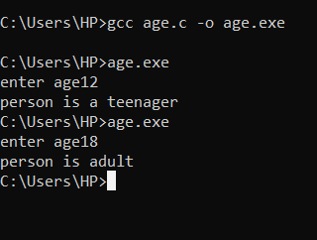

**QUESTION 2:**

**Create a program that determines if a number is positive, negative, or zero, and if it’s positive, checks if it’s an even or odd number.**

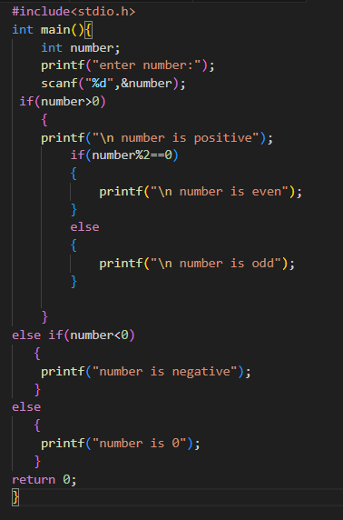

**OUTPUT:**

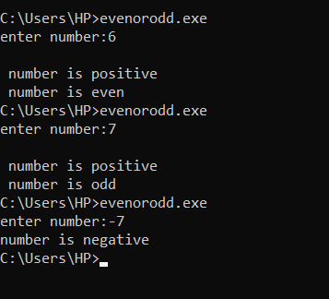

**QUESTION 3:**

**Write a program that checks if a number is divisible by both 3 and 5 using logical operators.**

**OUTPUT:**

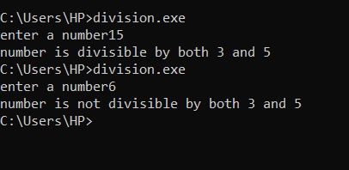

QUESTION 4:

Create a program that checks if a person is eligible to vote based on their age and citizenship status.

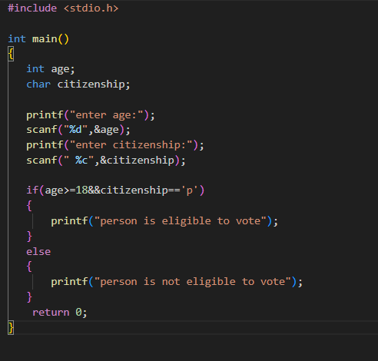

OUTPUT:

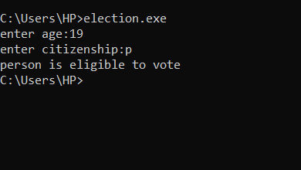

QUESTION 5:

Write a program using a ternary operator to find the maximum of two numbers.

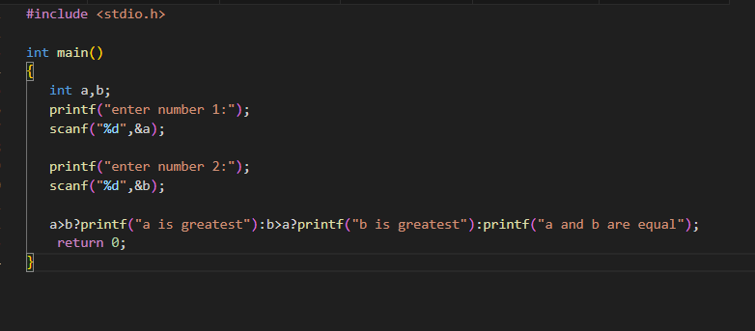

OUTPUT:

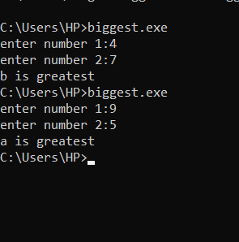

QUESTION 6:

Use the ternary operator to check if a number is positive, negative, or zero.

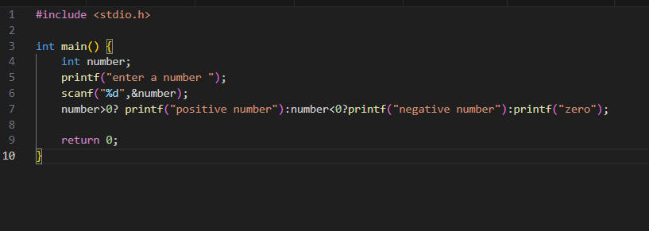

OUTPUT:

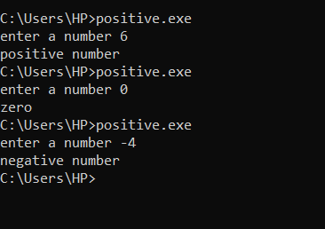

QUESTION 7:

Write a program to swap two numbers using bitwise XOR.

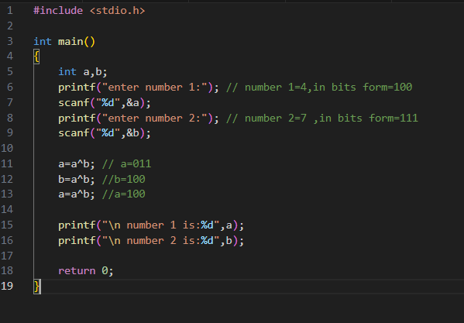

OUTPUT:

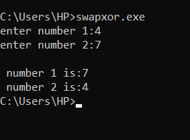

QUESTION 8:

Write a program that checks if a year is a leap year using the modulus operator.

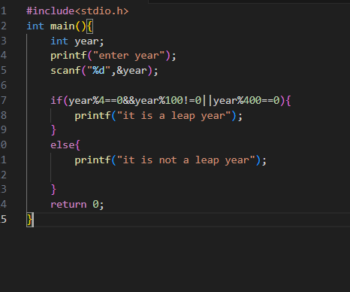

OUTPUT:

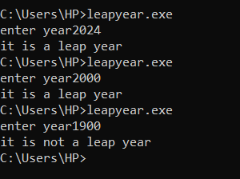

QUESTION 9:

Write a program to find the greatest of three numbers using nested if-else statements.

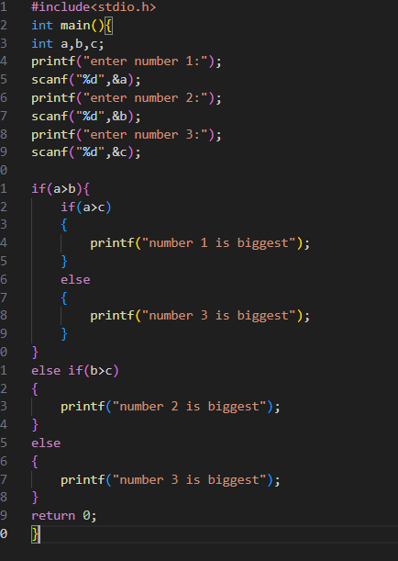

OUTPUT:

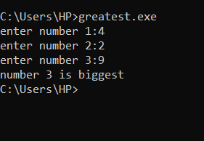

QUESTION 10:

Write a program that uses bitwise operators to perform encryption and decryption of a character.

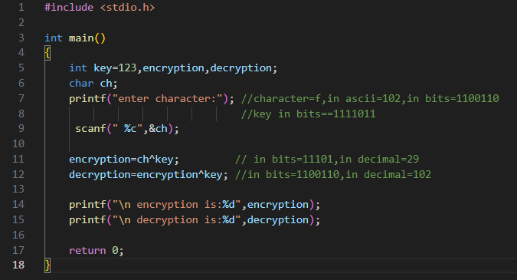

OUTPUT:

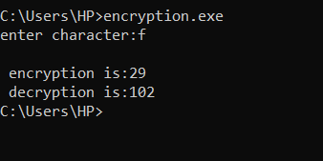

QUESTION 11:

Develop a program that uses logical operators to determine if a person is eligible for a loan based on age, income, and credit score.

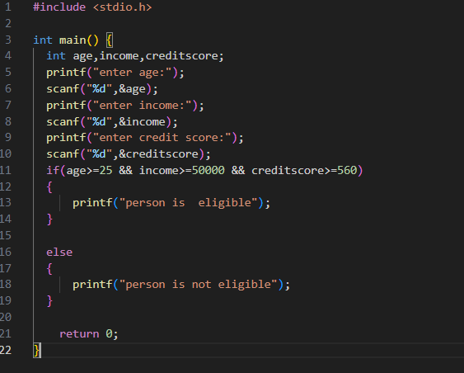

OUTPUT:

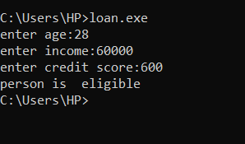

QUESTION 12:

Create a program that calculates the final grade of a student based on multiple

criteria, including attendance, assignment scores, and exam results, using nested decision structures.

OUTPUT:

